WJEC BY2 2.6 Adaptations for parasitism

* Parasites are organisms that **live on or in** another organism, called the host, and **obtain nourishment** at *the expense* of the host.
* 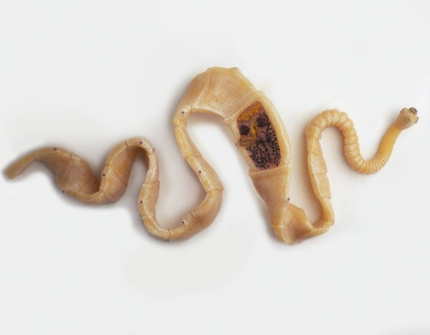The cestode (tapeworm) *Taenia solium* (pork tapeworm) is the main cause of human cysticercosis.

Life cycle of T. solium with resulting cysticercosis

* + Cysticercosis is an infection of both humans and pigs with the larval stages of the parasitic cestode, Taenia solium. This infection is caused by ingestion of eggs shed in the faeces of a human tapeworm carrier .

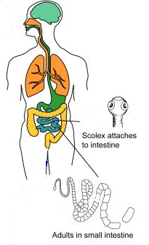



[](http://images.google.co.uk/imgres?imgurl=http://studentweb.tulane.edu/~djohnso6/poo.gif&imgrefurl=http://www.fullcontactpoker.com/poker-forum/index.php?showuser=30948&h=430&w=438&sz=7&hl=en&start=9&tbnid=QDvLxHnA54IUvM:&tbnh=125&tbnw=127&prev=/images?q=poo&gbv=2&hl=en)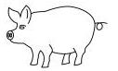

[](http://images.google.co.uk/imgres?imgurl=http://studentweb.tulane.edu/~djohnso6/poo.gif&imgrefurl=http://www.fullcontactpoker.com/poker-forum/index.php?showuser=30948&h=430&w=438&sz=7&hl=en&start=9&tbnid=QDvLxHnA54IUvM:&tbnh=125&tbnw=127&prev=/images?q=poo&gbv=2&hl=en)

* + Humans and pigs are infected by ingestion of food contaminated with faeces, which contains eggs.
  + 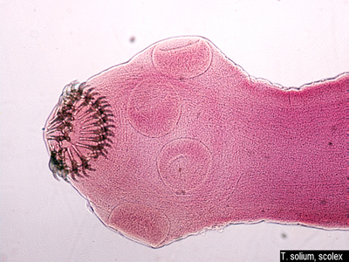Once eggs are ingested, the tapeworms hatch in the intestine, and penetrate the intestinal wall, where they are able to attach to it because on their scolex (head) they contain:
    - Two rows of hooks
    - Four “suckers”
* The following are the problems that the gut parasite has to overcome in order to survive:
* It lives **surrounded** by *digestive juices and mucus.*
* Food, mixed with digestive juices, is in ***constant motion*** as it is churned about as well as being propelled along the length of the gut by peristaltic contractions of the muscular wall.
* It lives in **extremes conditions** of **pH** along the length of the gut.
* The *immune system* of the host.
* If the **host dies** then so does the parasite.
* In order to survive the tapeworm must adapt by:
* Have a means of **penetrating** the host
* Have a means of **attachment** to the host
* **Protect itself** against the immune responses of the host
* Develop **only those organs** that are **essential** for survival – no need for digestive system as is already surrounded by digested food
* Produce **many eggs**
* Have an **intermediate host**
* Have **resistant stages** to overcome the period away from a host
* They have evolved the following structural modifications for their parasitic way of life:
* **Suckers** and **a double row of curved hooks** for **attachment** to the wall of the gut.
* A body **covering** which protects them from the host's immune responses.
* **A thick cuticle** and the **production of inhibitory substances** on the surface of the segments to prevent their digestion by the host's enzymes.
* The tapeworm is **very thin** and has a **large surface area to volume ratio**. It is surrounded by **digested food** so it has a very simple digestive system and pre-digested food can be absorbed over the entire body surface.
* Because the gut could not accommodate two tapeworms each segment **contains both male and female reproductive organs**. Vast numbers of eggs are produced, with each mature segment containing up to 40,000 eggs. The mature segments pass out of the host's body with the faeces. The eggs have resistant shells and can survive until eaten by the secondary host. Further development can then take place and the embryos which hatch from the eggs move into the muscles of the pig and remain dormant until the meat of the pig is eaten by a human.

|  |
| --- |
| * Because they live in a **stable environment** they do not need to move around and do not require a *sensory system*. This has led to the **degeneration of unnecessary organs.** They do have a simple excretory and nervous system but most of the body is concerned with reproduction. |

* Harmful effects of the pork tapeworm
  + The adult worms cause little discomfort but, if the eggs are eaten by humans, dormant embryos form cysts in various organs and damage the surrounding tissue. Adults can be treated with appropriate drugs. Public health measures and frequent inspection of meat are essential measures.