CORMS Practice

- Describe an experiment you could do to find out the effect of pH on the growth of yeast?

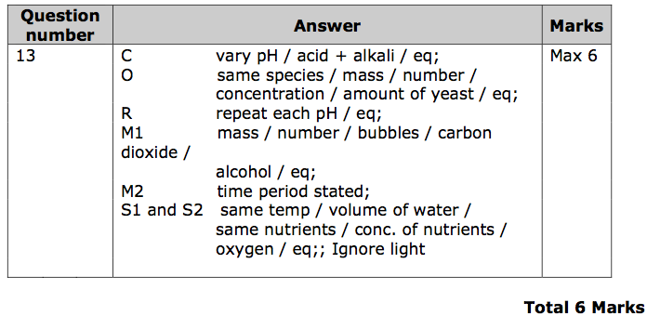
2.
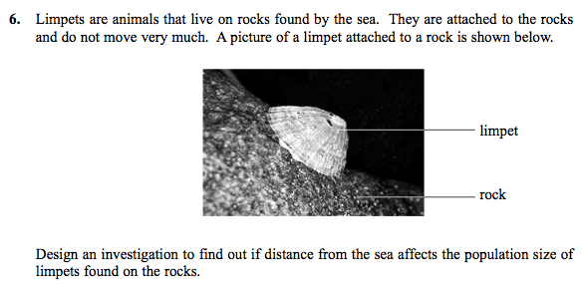

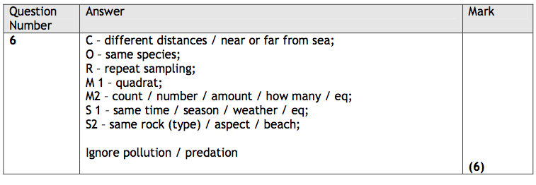

- Describe an investigation you could do to find out the effect of carbon dioxide concentration on the movement of insect larvae.

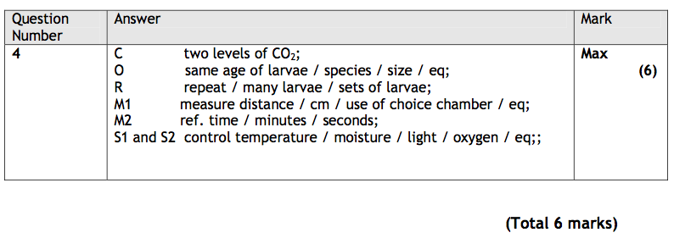
- Describe an investigation you could carry out to find the effect of different air temperatures on the rate of sweating in humans.

Include full experimental details in your account.

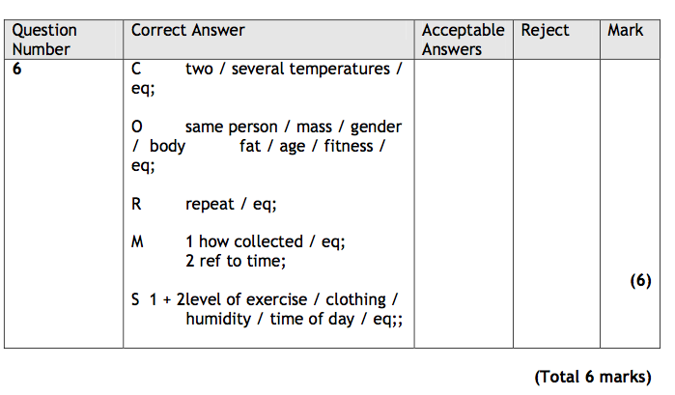

5.

