Biology in Remove
Your task: to create a poster entitled...
“Tropisms”
The level ladder is below. To achieve a certain level, you must achieve everything on the rungs below as well.
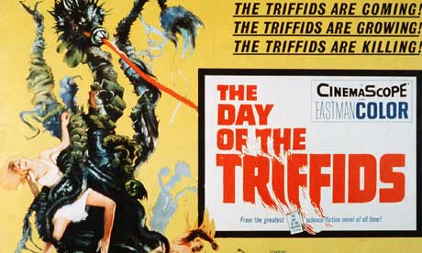
Grade D
List stimuli that plants respond to
Grade C
Describe the main types of tropism - include concepts such as positive and negative tropism
Grade B
Describe how plant hormones, specifically auxins, enable tropism to occur
Grade A
Explain how plant hormones can be used by human beings for economic or social gain
Grade A*
Compare different groups of plant hormones including auxins, gibberelins and cytokinins

