Option G.4 Notes
G.4.1 Explain the use of biotic indices and indicator species in monitoring environmental change
Indicator species are sensitive to specific environmental conditions and consequently have a limited range of tolerance
Their population growth, reduction or disappearance indicates specific changes in the environment, making them a useful means of monitoring change
Indicator species may be sensitive to a number of different environmental conditions:
- Lichen, along with mosses, are susceptible to air-borne pollutants dissolved in water (e.g. sulphur dioxide)
- Tubifex worms are sensitive to concentrations of heavy metals
- Mayfly larvae and certain aquatic invertebrates are sensitive to dissolved oxygen levels in water
Biotic indices compare the relative frequency of indicator species and is calculated to provide an overall environmental assessment of an ecosystem
Calculating biotic indices involves multiplying the population size of each indicator species by its pollution tolerance rating
- A high biotic index indicates an abundance of pollution sensitive organisms and hence denotes an unpolluted environment
- A low biotic index indicates the absence of indicator species and an abundance of pollution tolerant organisms (hence a polluted environment)
- A change in the biotic index over time marks a change in the environmental conditions within the ecosystem
Indicator Species (will not be present at higher pollution levels)
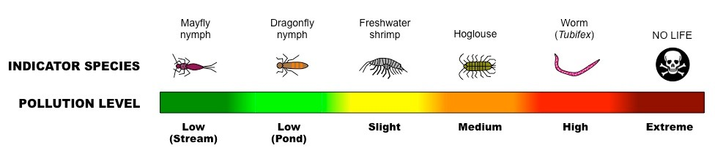
G.4.2 Outline the factors that contributed to the extinction of one named animal species
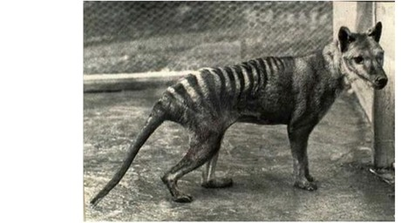
- Extinction is the cessation of a species or higher taxon level, reducing biodiversity
- The Tasmanian tiger (Thylacinus cynocephalus) became extinct after the arrival of European settlers to Australia and the introduction of sheep
- Tasmanian tigers would feed on the introduced sheep and were subsequently hunted by man, causing numbers to rapidly decline
- The loss of habitat to human development and the lack of successful breeding programs in zoos saw population numbers dwindle
- The last Tasmanian tiger died in captivity in 1936 and they were declared extinct by international standards in 1986
- Aboriginal rock paintings suggest the Tasmanian tiger once lived on mainland Australia but died out from predation and competition from dingoes
G.4.3 Outline the biogeographical features of nature reserves that promote the conservation of diversity
Biological conservation involves setting aside land for restricted access and controlled use to allow for the maintenance of local biodiversity
- Nature reserves will typically show certain biogeographical features that help to promote the conservation of diversity:
Size
- Larger nature reserves usually promote conservation better than smaller nature reserves
- Larger reserves allow for the mobility of far-ranging animals (e.g. grizzly bears) and have proportionally smaller perimeters (less affected by 'edge')
Edge Effect
- Ecology at the edges of ecosystems is different from central areas due to edge effects (e.g. more sunlight, more wind, external predators, etc.)
- As organisms living near the edge of an ecosystem have more competition from other species, certain species will flourish where there are less edges
- However certain species will favour edge environments (e.g. the brown-headed cowbird)
- Fragmentation of forests will increase egde effect by reducing the central areas of fragmented reserves
Habitat Corridors
- Habitat corridors (e.g. tunnels under roads, narrow belts of bushland) allow the movement of wildlife between different parts of a fragmented habitat
- Habitat corridors connect otherwise isolated habitats, increasing total size of the reserve and improving genetic diversity
General Principles of Nature Reserves (exceptions may exist depending on composition of local wildlife)
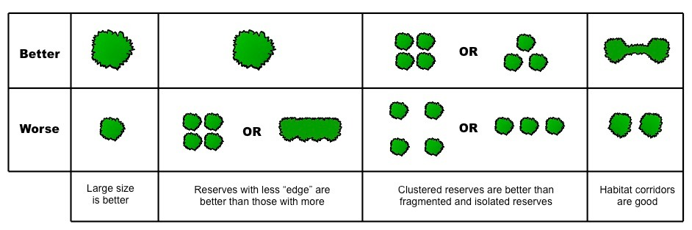
G.4.4 Discuss the role of active management techniques in conservation
Biological conservation requires constant and continual management of the environment, including:
- Maintenance of effective boundaries (protection from poachers and invasive species)
- Restoration of degraded areas (maintaining habitat conditions in their original state)
- Measures to facilitate the successful completion of species' life cycles (e.g. nesting boxes for birds)
- Promotion of recovery of endangered species (restocking / reintroducing species whose populations are low)
G.4.5 Discuss the advantages of in situ conservation of endangered species (terrestrial and aquatic nature reserves)
- In situ conservation describes the preservation of an endangered species 'on site' (i.e. in its natural habitat or nature reserve)
- Such conservation allows species to live in the environment to which they are adapted and to occupy their natural position in the food chain
- In situ conservation maintains the animal's normal behaviour (offspring usually aquire skills from parents and peers around them)
- Retaining the natural habitat prevents its eventual loss and ensures it remains available for other endangered species
- Such reserves provide a place to return animals from breeding programs as they provide more realistic conditions for reintegration
- Reserves in different regions of the world can share information and provide a place for scientific study and developing public awareness
G.4.6 Outline the use of ex situ conservation measures, including captive breeding of animals, botanic gardens and seed banks
Ex situ conservation describes the preservation of an endangered species away from its natural habitat
- Such conservation may involve captive breeding of animals (e.g. zoos), botanical gardens and seed banks (stored supplies of seeds)
Advantages:
- Ex situ conservation allows for greater control of necessary conditions (e.g. climate control, dietary intake, veterinary care, etc.)
- Such methods can improve the chances of successful breeding by allowing the use of artificial methods (e.g. embryo transfer, IVF, etc.)
Disadvantages:
- Species raised in captivity are less likely to be successfully reintroduced into the wild and does not prevent the destruction of their natural habitat
- Ex situ conservation increases inbreeding by restricting the gene pool and reduces evolution as species are not in their natural habitat

