Support worksheet – Option G
1 The map below shows the distribution of the shingleback lizard in Australia. The shingleback lizard feeds on vegetable matter including foliage, berries, fruits and flowers. It may also eat insects, spiders, snails or scorpions. The species was once preyed upon by dingoes and pythons but they are now threatened by introduced species such as foxes and cats. The habitat of the species includes shrub land, desert grassland and sandy dunes. They are often seen basking along roadsides or other cleared areas.
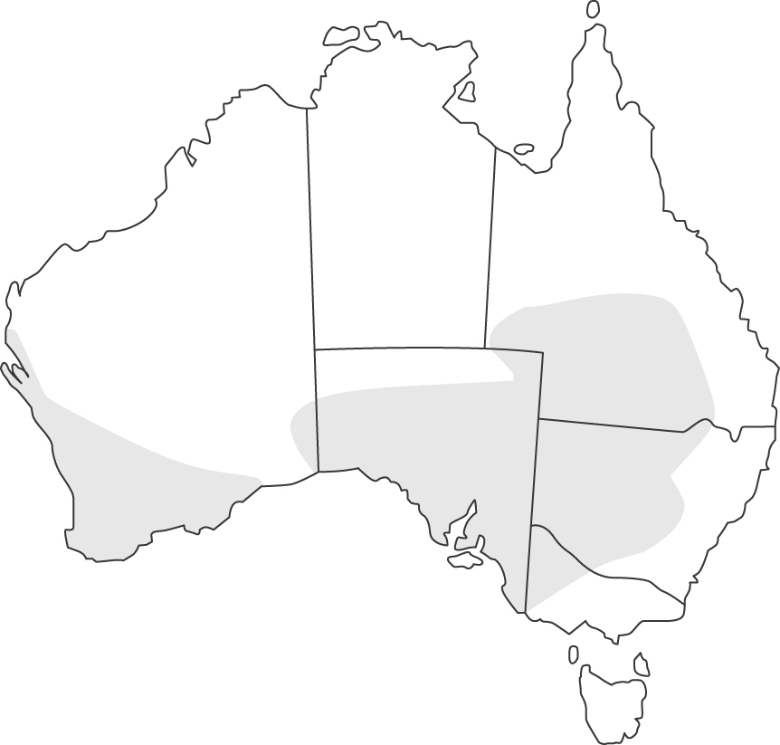
The following map shows the distribution of the frill-necked lizard. An adult is 70–90 cm long. These lizards feed on invertebrates such as insects and spiders but will occasionally eat small vertebrates, including mammals and other lizards. These lizards are active during the day, particularly during the wet season.
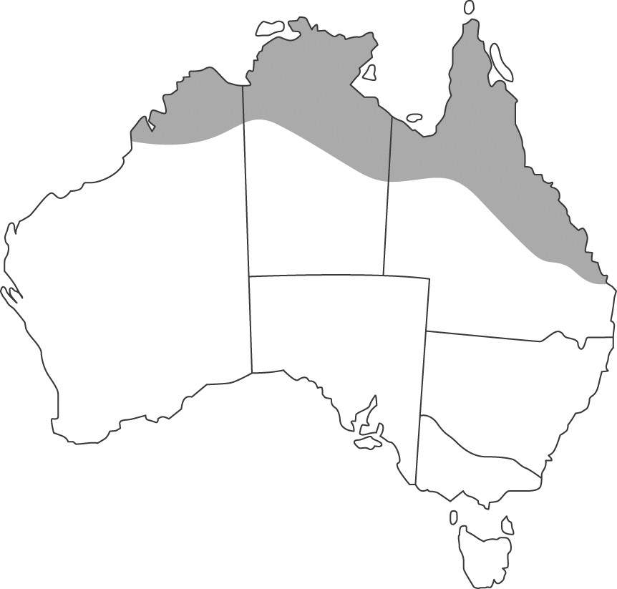
a Suggest three factors that may affect the distribution of the two species of lizard. (3)
b Describe a method that could be used to sample the populations of lizards to determine how their distributions are influenced by rainfall. (2)
c What are the limitations of the method you have described? (1)
d Comment on the difference between the fundamental and realised niches of the shingleback lizard. (4)
2 Abandoned cornfields have been the sites of investigations concerning ecological succession, which is the orderly progression of changes in the plant and animal life of an area over time. The diagram shows such a succession.
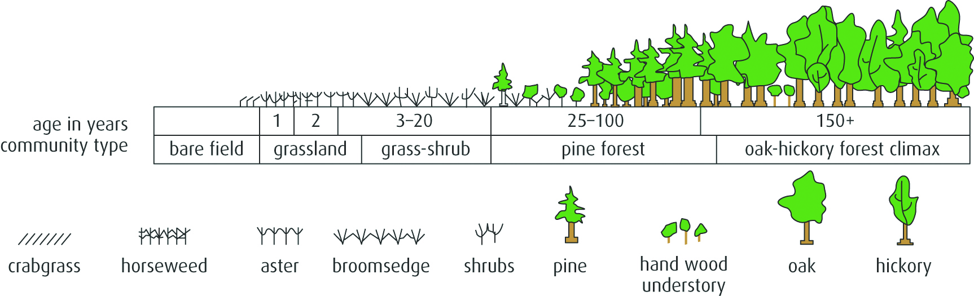
a Is this an example of primary or secondary succession? Explain your answer. (2)
b Which of the following statements about succession is correct? (1)
A Secondary succession occurs where no soil exists.
B Primary succession occurs in areas where soil remains after a disturbance.
C Secondary succession can occur where a disturbance has left soil intact.
D Some cases of succession involve facilitation, a phenomenon in which local species inhibit the growth of newcomers.
c Suggest why grasses are among the first species to colonise the abandoned cornfield. (1)
d Comment on the number of species likely to be present, and the quantity of biomass as time passes. (2)
e The total amount of energy trapped in the organic matter of photosynthetic autotrophs present in an area, in a period of time, is known as: (1)
A gross production
B standing crop
C net production
D secondary production
E trophic efficiency
3 a State whether these statements are true or false.
i An ecosystem’s trophic structure determines the rate at which energy cycles within the system. (1)
ii At any point in time, it is impossible for consumers to outnumber producers in an ecosystem. (1)
iii Chemoautotrophic prokaryotes that use energy from chemical reactions to generate ATP near deep-sea vents are primary producers. (1)
iv There has been a well-documented increase in atmospheric carbon dioxide over the past several decades. (1)
v Both iii and iv are true. (1)

b Define ‘biomagnification’. (1)
c The data in the diagram and the table below show the concentration of mercury in various organisms. Calculate the increase in concentration of the mercury:
i between algae and mayfly (1)
ii between sunfish and heron. (1)
Pesticide in body tissue | Parts per million
great blue heron | 75
sunfish | 2
mayfly | 1.1
algae | 0.05
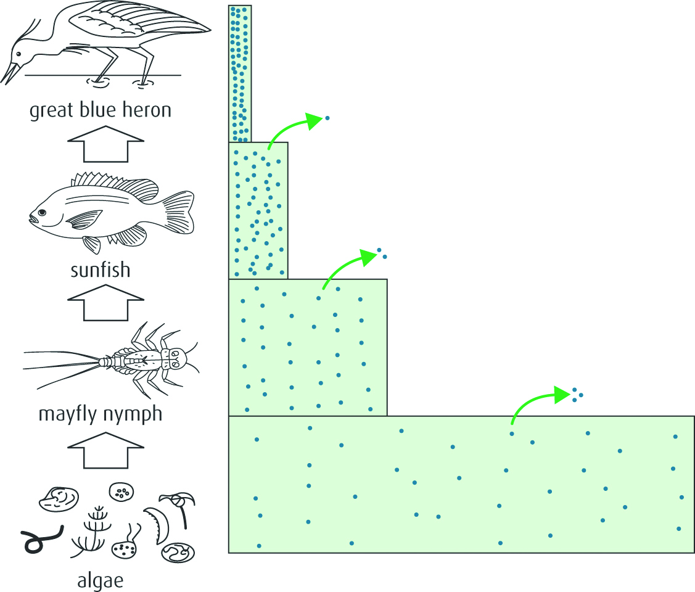
d What do the figures suggest about mercury as a pollutant? (1)
e Why are top consumers most at risk from biomagnification? (2)

