The Endocrine System
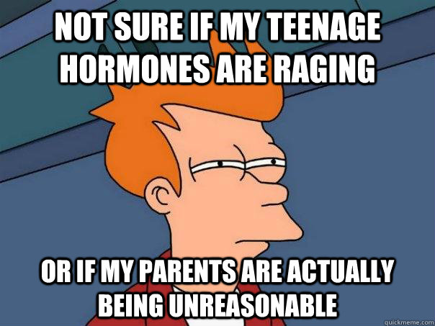
Hormones, man!
ADH, adrenaline, insulin, testosterone, progesterone and oestrogen
Grade C
State where in the body these hormones are produced
Grade B
Describe the effects of these hormones
Grade A
Explain the role of these hormones in homeostasis
Grade A*
Compare how the endocrine system and the nervous system are involved with homeostasis

